**Name: laiba asif**

**Student Number: R00201303**

**Class Group: comp1DY**

**Lab 6 – Adders**

1. Complete the following truth table for a binary half adder:

# Truth Table:

|  |  |  |  |
| --- | --- | --- | --- |
| A | B | Carry | Sum |
| 0 | 0 | 0 | 0 |
| 0 | 1 | 0 | 1 |
| 1 | 0 | 0 | 1 |
| 1 | 1 | 1 | 0 |

1. Using the truth table above, design a half adder circuit which adds two bits.

## Circuit:

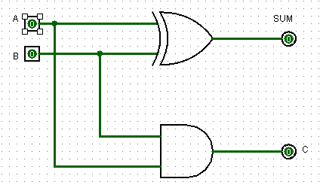

|  |  |  |  |
| --- | --- | --- | --- |
| A | B | SUM | C (OUTPUT) |
| 0 | 0 | 0 | 0 |
| 0 | 1 | 1 | 0 |
| 1 | 0 | 1 | 0 |
| 1 | 1 | 0 | 1 |

1. Draw the black box representation of a half adder.

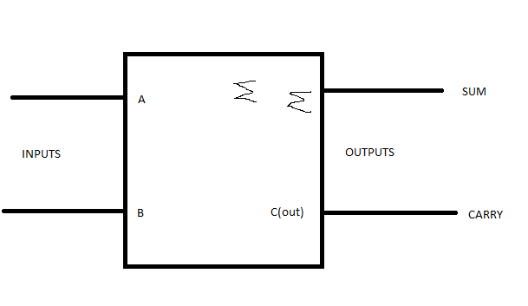

1. Complete the following truth table for a full adder:

|  |  |  |  |  |
| --- | --- | --- | --- | --- |
| A | B | C | Carry | Sum |
| 0 | 0 | 0 | 0 | 0 |
| 0 | 0 | 1 | 0 | 1 |
| 0 | 1 | 0 | 0 | 1 |
| 0 | 1 | 1 | 1 | 0 |
| 1 | 0 | 0 | 0 | 1 |
| 1 | 0 | 1 | 1 | 0 |
| 1 | 1 | 0 | 1 | 0 |
| 1 | 1 | 1 | 1 | 1 |

1. Using the black box representation of a half adder (from Q.3), design a full adder which is capable of adding two bits and a carry-in bit.

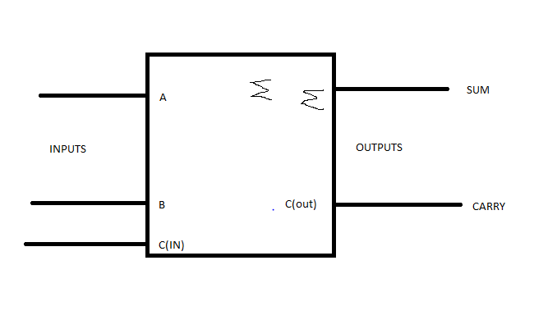

1. Implement the full adder design in Logisim using XOR, AND and OR gates.

## Circuit:

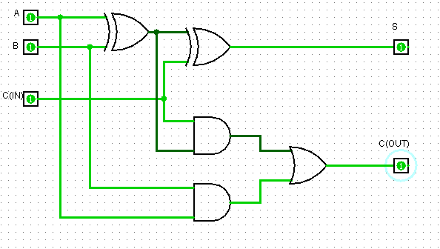

1. Using the partial circuit given on Canvas, ripple-burst.circ, complete the ripple carry adder which is capable of adding two 4-bit numbers. Test your circuit by adding the following 4-bit numbers (include a screenshot for each sum):
   1. 1101 + 0001=14=1110
   2. 1001 + 0011=12=1100
   3. 0010 + 0011=5=0101
   4. 1001 + 0001=10=1010
   5. 0011 + 1010=13=1101
   6. 1100 + 1001=5=0101

## Circuits:

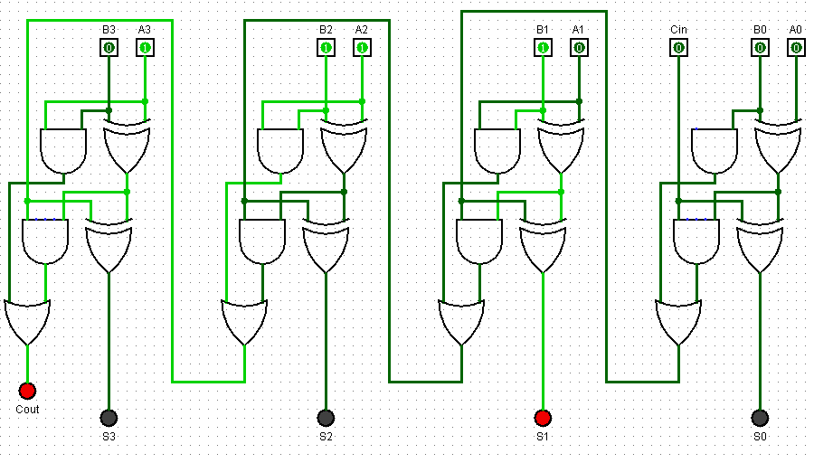

1. Using a black box design (i.e. use black box full adder blocks), draw the 4-bit ripple carry adder below:

